

Sample construction of Silca System box stairs on any deck platform. Wood boxes are constructed as required to achieve the appropriated riser height and tread width taking into account the height
of the Silca grate (1.5'') and the height of the stone used. The boxes are placed on a Silca grate base to protect against moisture damage.


Silca
Silca
Wood
Silca grate base
Silca
Silc
S a
Silc
Stone
Deck Base
a
c
il
a
For discussion purposes only

Sample construction of Silca Stairs using wood Stair Stringers

Stone steps and fascia
Wood
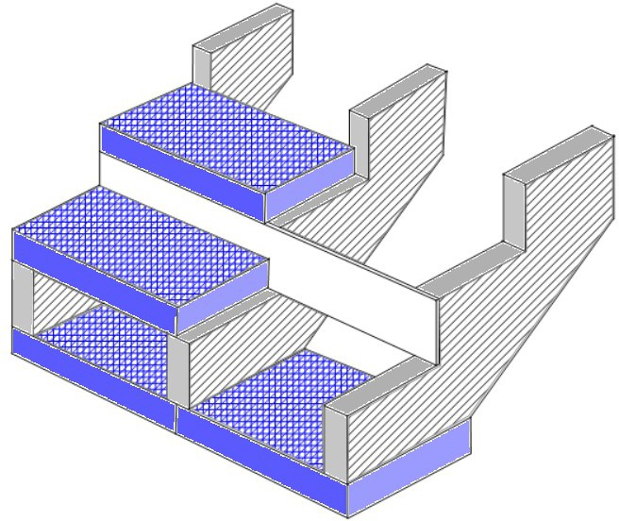Stair stringers on 16'' centers

Wood Stair stringers
Silca Grates

Silca grate base for stringers

For discussion purposes only
Cement board can be added to help adhere riser stone

