APPLICATION DETAILS - NEW CONSTRUCTION SECTION VIEWS
STONEDEKS SYSTEM
14600 COMMERCE STREET NE ALLIANCE, OHIO 44601
PHONE: (330) 821-1585
www.stonedeks.com

 | EXISTING STRUCTURE
PAVER (OR MANUFACTURED STONE)
SILCA GRATE
JOISTS | ATTACHMENT TO EXISTING
BEAM PER TABLES | STRUCTURE PER LOCAL  CODE
UP TO 12" CANTILEVER

1'

GRADE
GRADELOCALDEPART MENT

JOIST SPAN "L"

6X6 NO.2 SYP TREATED COLUMN, UP TO 10' ABOVE GRADE

CONCRETE FOOTING PADS PER TABLES

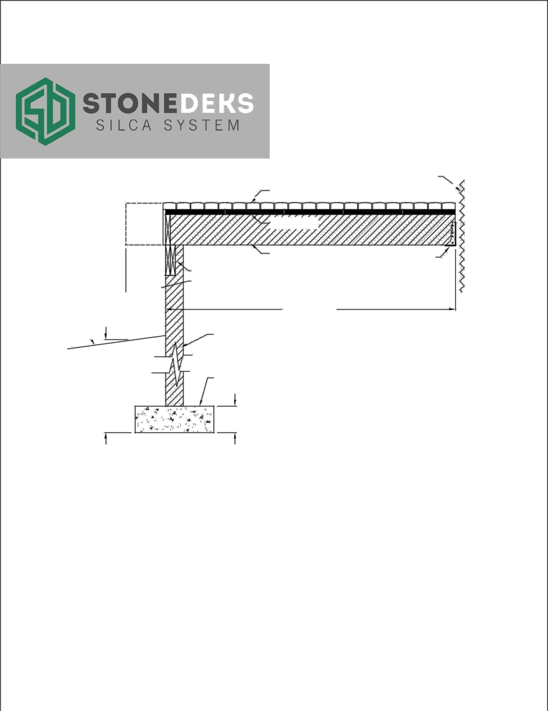
DEPTH BUI LDING
BELOWP

DIAMETER
THIC
NEW CONSTRUCTION SECTION
MAXIMUM JOIST SPANS "L" - WHEN USING PAVERS 3/4" TO 3" THICKNESS
 | NATURAL STONE OR MANUFACTURED CONCRETE PAVER THICKNESS
JOIST SIZE | 3/4" | 1 1/4" | 2" | 2 1/2" | 3"
2X6 | 8'-9" | 8'-  5" | 7'-10" | 7'-5" | 7'-2"
2X8 | 11'-  4" | 10'-  9" | 10'-0" | 9'-6" | 9'-2"
2X10 | 13'-  7" | 12'-  10" | 11'-  11" | 11'-4" | 10'-  11"
2X12 | 16'-  0" | 15'-  2" | 14'-1" | 13'-4" | 12'-  10"
NOTES:
- INSTALLATION TO BE COMPLETED IN ACCORDANCE WITH MANUFACTURER'S SPECIFICATIONS.
- DO NOT SCALE DRAWING.
- THIS DRAWING IS INTENDED FOR USE BY ARCHITECTS, ENGINEERS, CONTRACTORS, CONSULTANTS AND DESIGN PROFESSIONALS FOR PLANNING PURPOSES ONLY. THIS DRAWING MAY NOT BE USED FOR CONSTRUCTION.
- FOR PRODUCT AND COMPANY INFORMATION VISIT WWW.STONEDEKS.COM OR CALL
330-821-1585.
StoneDeksTM- revised 2.2018

